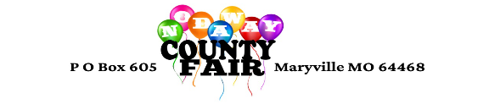
2024 COMMERCIAL EXHIBIT REGISTRATION

The Nodaway County Fair would like to extend to you an invitation to participate in the 2024 fair as an exhibiter. The dates for the 2024 fair are July 11, 12 and 13.

Available booth spaces will be outside and have an approximate 15ft by 8ft

Please indicate one:

__Pd.___ Commercial booth - $150.00 per approx. 15ft by 8ft spot

Electricity $50.00 for the event. Yes _____ No _____
220 service must be prearranged and will cost $75.00
You may connect to electricity only after our electrician has inspected your unit's electrical system.

Indicate days you will attend: 11 _____ 12_____ 13 _____

Name Business \ org.: ______________________________________________________
Address: ____________________________________________________________________
Phone #: ________________ Contact Person: _________________________________
Description of Booth & what you are selling: ____________________________ ______________________________________________________________________________
______________________________________________________________________________
Signature: __________________________________________ Date: _________________

Return to: Jeremy Walker Questions: (660) 853-1740
27265 242nd Street
Maryville, MO 64468
Make Checks Payable to: Nodaway County Fair

Note: You are responsible for any supplies you need (elec. Cords, tables, chairs, etc.). The Nod. Co. Fair Board or the City of Maryville is no responsible for anything lost, stolen or damaged.

To guarantee a place a check for electricity and proof of insurance (if you have) must accompany this registration.

